**图像配准作业说明**

**（以标注4个点为例）**

**一．手动标点：**

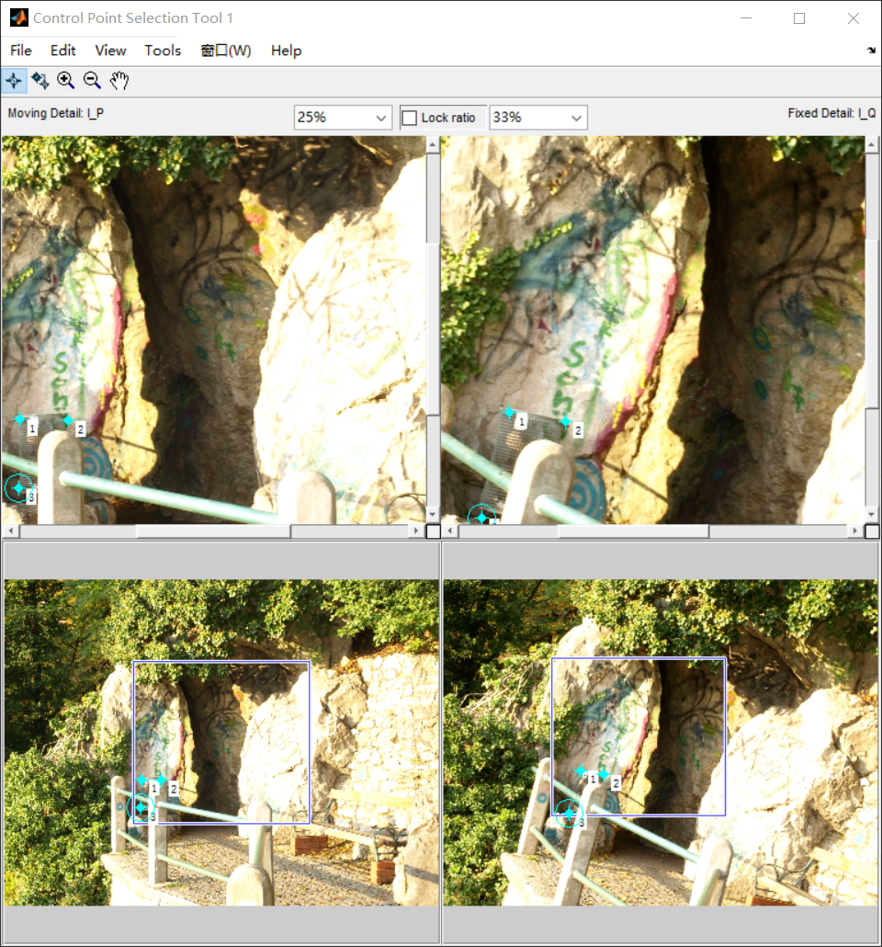

**二．输出两幅图中对应点的坐标：**

fixedPoints3 =

911.327047413793 1237.06896551724

750.750809061488 355.427184466019

1817.65247844828 858.933189655172

1791.87055016181 1626.40453074434

1253.43318965517 1547.74066091954

1994.68608414240 2025.27508090615

632.135775862069 1403.67169540230

movingPoints3 =

1181.20536692223 1696.14074479737

837.582146768894 861.056407447973

1972.33789704272 1088.80668127054

2160.13198247536 1867.95235487404

1580.76725082147 1903.91292442497

2434.50000000000 2158.50000000000

966.500000000000 1914.50000000000

**三．计算转换矩阵：**

计算转换矩阵H可利用MATLAB中的相应函数进行计算。

H:

0.974238239984244 -0.261968597935023 185.080548325121

0.232461591857355 0.997313126879064 -721.196220664131

4.66232103681919e-20 -3.11792121025587e-20 1

**四．输出转换之后的图像：**

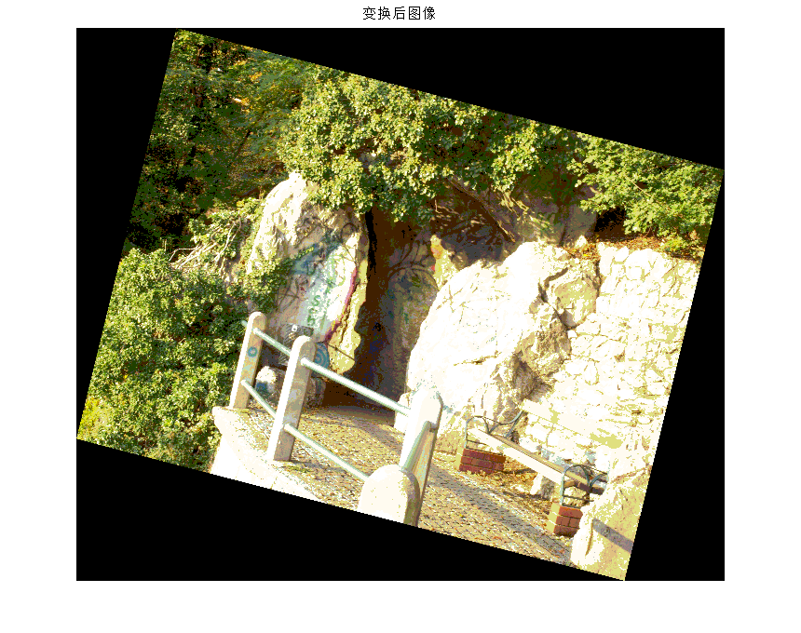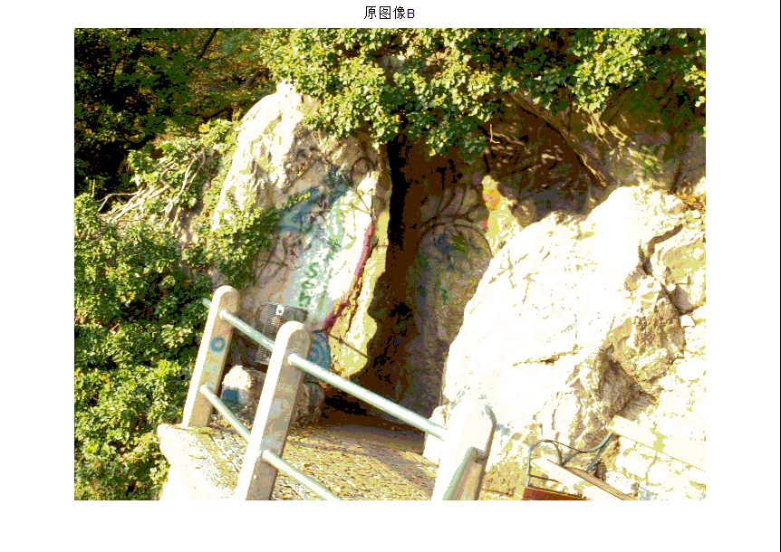

**五．代码示例：**

%% Ñ¡µã²¢¼ÆËã·ÂÉä±ä»»

I_P = imread('C:\Users\chenyuehai\Desktop\a.jpg');

I_Q = imread('C:\Users\chenyuehai\Desktop\b.jpg');

cpselect(I_P,I_Q);

tform=cp2tform(movingPoints1,fixedPoints1,'affine');

I_O=imtransform(I_P,tform);

movingPoints

fixedPoints

%% Êä³öÍ¼Ïñ

figure(1)

imshow(I_P);

title('Ô­Í¼ÏñA');

figure(2)

imshow(I_O);

title('±ä»»ºóÍ¼Ïñ');

figure(3)

imshow(I_Q);

title('Ô­Í¼ÏñB');

**六．心得体会：**